A REPORT
ON

GOVERNMENT SCHEME FRAUD DETECTION SYSTEM

Submitted by

TEAM APEX : FXH26-P-BDDS-006

BACHELOR OF TECHNOLOGY
IN

COMPUTER SCIENCE AND ENGINEERING (DATA SCIENCE)/

AT



PRESIDENCY UNIVERSITY BENGALURU

Name: B. Nanda Kumar Reddy  Roll No:20241CSD0022 |  | Name: Manohar  Roll No: 20241CSD0041
Name: Dileep Gowda R N  Roll No:20241CSD0007 |  | Name: Vishnupriya .T.S  Roll No: 20241CSD0042

PROBLEM STATEMENT:

Fraud activities in government schemes can lead to misuse of public funds which can lead to reduction of welfare programs. Detecting such fraud manually is difficult due to large amount of raw data. This project aims to identify fraud patterns using machine learning techniques and predict any kind of potential future risks that must be avoided or for which precautions could be taken.

OBJECTIVE:

The objective of this project is to develop an intelligent system that detects potentially fraudulent applications by analysing behavioural patterns like increase and decrease in transaction amount ,presence of duplicate ID’s or applications , financial inconsistencies, and transaction activity. The system also aims to provide risk-based insights to identify and prevent potential future fraud cases.

DATASET DESCRIPTION:

A synthetic dataset was created to simulate real-world fraud scenarios. The dataset includes the following features:
- ApplicantID → Unique identifier for each applicant
- Name → Name of the applicant
- Age → Age of the applicant
- Income → Monthly income of the applicant
- SchemeType → Type of scheme applied
- ApplicationCount → Number of times the applicant applied for the scheme
- TransactionCount → Number of times transactions made
- ClaimedAmount → Amount claimed by the applicant
- AvgClaimAmount → Average claim amount across applications
- LocationRisk → Risk level of the applicant’s location
- DuplicateID → Indicates whether identity is reused (0 = no, 1 = yes)
- AmountTrend → Pattern of claim amounts over time (increasing or decreasing)

METHODOLOGY:

A synthetic dataset was generated based on predefined attributes such as age, income, number of applications, transaction count, location risk, duplicate identity usage, requested amount, and scheme type. Logical rules were applied to simulate fraud patterns by assigning higher fraud probability to cases with repeated applications, high transaction counts, presence of duplicate IDs, high-risk locations, and unusually large claim amounts relative to income.
Categorical features such as scheme type were converted into numerical format using one-hot encoding. The dataset was then used to train a Logistic Regression model, which learns patterns from these attributes to classify whether an application is fraudulent or genuine.

SYSTEM WORKFLOW:

- Dataset generation
- Data preprocessing and encoding
- Model training using Logistic Regression
- Fraud prediction using trained model
- Risk analysis and identification of high-risk users

RESULT:

The system successfully predicts fraudulent applications and provides insights into potential future fraud cases. The model output provides both, classification results and fraud probability scores, which help in identifying high-risk users and avoid common fraud patters.
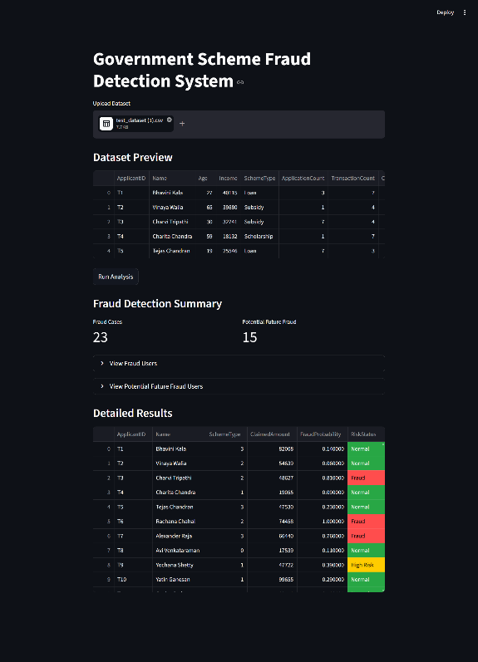
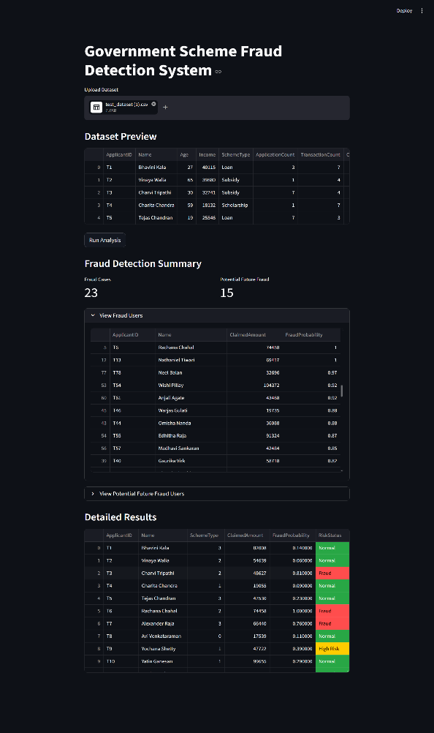

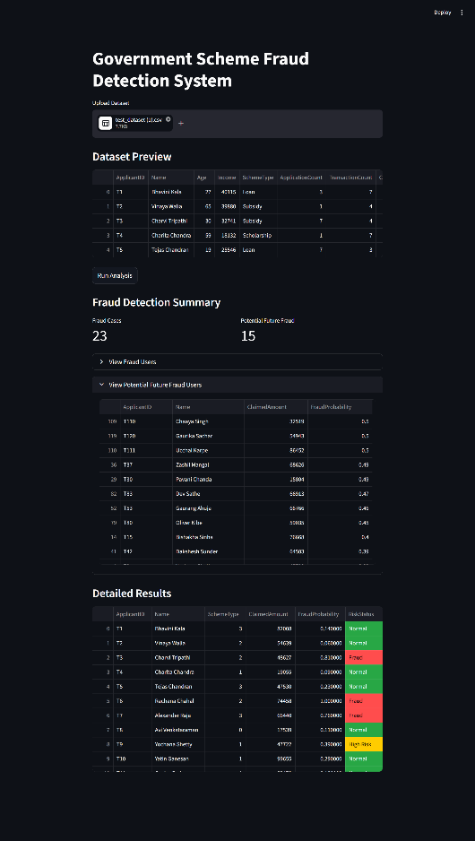

CONCLUSION:

The developed system can help in detecting suspicious activities in government schemes and reduce financial losses. By analysing ,behavioural and financial patterns, the model helps in identifying repeated patters and provides an effective approach for early fraud detection .

The system can be extended to work with real-world datasets such as government or financial data sources like RBI or OGD. It can also be integrated into a web-based platform for real-time fraud monitoring and decision-making.

